Which model gives best results :

# **Confusion Matrix:**

|  |  |
| --- | --- |
| **Accuracy** | **Correctly Predicted / Total** |
| **Recall** | **TP/TP+FN** |
| **Precision** | **TP/TP+FP** |
| **F1 Score** | **2*Recall*Precision/Recall+Precision** |

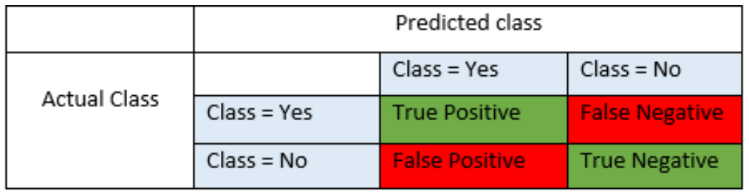

* **It is difficult to compare two models with low precision and high recall or vice versa.**
* **F-score helps to measure Recall and Precision at the same time.**
* **For our investigation RANDOM FOREST has the highest average F1-score for Buy Hold Sell**

# **Random Forest**

accuracy **0.61**

precision recall f1-score support

Buy 0.77 0.56 0.65 152

Hold 0.49 0.69 0.57 131

Sell 0.66 0.59 0.62 137

# **LOGISTIC REGRESSION**

accuracy **0.59**

precision recall f1-score support

Buy 0.69 0.62 0.66 152

Hold 0.52 0.49 0.50 131

Sell 0.56 0.65 0.60 137

# **SUPPORT VECTOR MACHINES**

accuracy **0.58**

precision recall f1-score support

Buy 0.64 0.60 0.62 152

Hold 0.50 0.57 0.53 131

Sell 0.62 0.58 0.60 137

# **NAIVE BAYES CLASSIFICATION**

accuracy **0.55**

precision recall f1-score support

Buy 0.65 0.46 0.54 152

Hold 0.47 0.54 0.50 131

Sell 0.56 0.66 0.61 137